**System Test Procedure Specification**

* 1. **Test Case Specification Identifier**

TPS-01-01

* 1. **Purpose**

This procedure describes the steps necessary to perform the test specified in the test design specification for PlasmaGraph feature “Inspect Data” TCS-01-01 **[see *TDS-01-XX section 2.4*]**.

* 1. **Special requirements**

No special requirements are needed to execute this test.

* 1. **Procedure steps**

1. ***Execute PlasmaGraph***

In order to launch the application the tester must click on the PlasmaGraph icon.

1. ***Import the data file provided into PlasmaGrap***

To import the data file provided the tester have to click on the data option located in the top menu of the tool bar. After doing this a menu with two more options will appear. Click on “Import Data”.

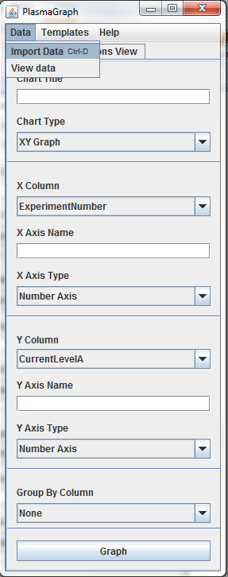

1. ***Inspect data***

To view the data contained in the file imported in step 4.2 the tester must click on data and then view data. These options are located in the tool bar as described in the figure below.

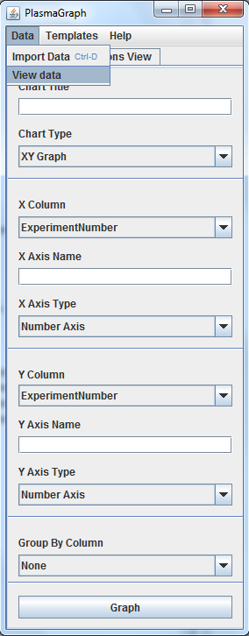

1. ***Compare outputs***

The tester must examine the data displayed by the program and determine if it complies with the expected output specified in the test case specification for this case ***[see document TCS-01-01 section 4]***.

1. ***Repeat for other OS***

Repeat steps 4.1 through 4.6 under the following operative systems:

1. Windows 7
2. Ubuntu Linux 14
3. Mac OS X 10